Understanding Customer Purchase Behavior and Sales Trends in Online Retail Store using Data Visualisation.
Pratibha Singh
Department of Computer and Communication Engineering, Lakshmi Narain College of Technology Indore, India vikrah0921@yahoo.com,
Abstract: —This project explores data analytics and visualization using an Online Retail Dataset. The study aims to identify sales patterns, customer demographics, payment preferences, and satisfaction levels through interactive visualizations. Data preprocessing and cleaning waa done on python to ensure accuracy and consistency, followed by the creation of dashboards in Power BI and Tableau to uncover insights. The dataset, encompassing one year of retail transactions across multiple cities and product categories, serves as a practical example to uncover patterns in customer behavior, product performance, payment preferences, and satisfaction trends. The various findings and trends in these habits have been analysed and have been discussed further in the report. This study demonstrates how data visualization converts raw data into actionable insights, supporting informed decision-making in e-commerce.

I. INTRODUCTION .
This project focuses on applying data analytics and visualization tools to an online retail dataset. The primary goal is to analyze how product categories, cities, payment methods, and demographics influence sales and customer satisfaction. Using Power BI and Tableau, the study demonstrates the process of transforming large datasets into visually meaningful insights that drive business intelligence.
Objectives:
- Clean and preprocess the retail dataset for analysis.
- Analyze customer demographics and purchasing trends.
- Identify top-selling products and categories.
- Examine the relationship between payment methods and sales.
- Develop interactive dashboards to visualize patterns effectively.
II. LITERATURE REVIEW
The online retail dataset used in this study has been referenced in multiple analytics projects to demonstrate data cleaning, exploratory analysis, and storytelling. By extending these approaches using Power BI and Tableau, this report showcases a complete data analysis pipeline that merges statistical insight with visual communication referenced in multiple analytics projects to demonstrate data cleaning, exploratory analysis, and storytelling. By extending these approaches using Power BI and Tableau, this report showcases a complete data analysis pipeline that merges statistical insight with visual communication
III. METHODOLOGY
A. Data Cleaning
Data cleaning was conducted in Python (pandas, NumPy) to prepare the dataset for analysis and visualization.
Key Steps:
- Import & Inspection
○ Loaded the online retail CSV dataset.
○ Inspected column data types and detected missing or inconsistent values.
- Handling Missing Values
○ Replaced missing review scores with category-wise averages.
○ Filled missing gender entries with “Unknown.”
- Standardization & Encoding
○ Standardized categorical fields (e.g., category name, payment method).
○ Converted order_date into proper datetime format for time-based analysis.
- Feature Engineering
○ Created total_sales column ○ Extracted year and month from order date.
○ Grouped customers by age_group (Youth, Adult, Mature, Senior).
- Export for Visualization
○ Cleaned dataset saved as CSV for import into Tableau and Power BI.
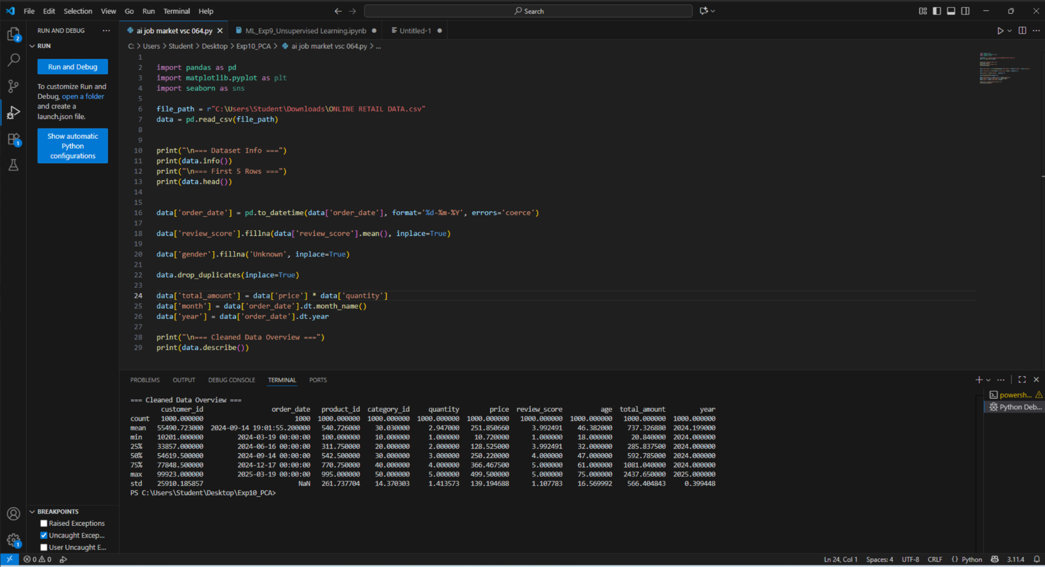
DATA CLEANING IN PYTHON

TOOLS USED
Stage | Tool
Data Cleaning | Python, pandas, NumPy
Visualization | Tableau, Power BI
Documentation | MS Word / LaTeX

III. DATA VISUALIZATION AND ANALYSIS
The cleaned dataset was visualized using multiple dashboards in Power BI and Tableau. These dashboards explored various aspects of online retail data, including category sales, gender-based patterns, and satisfaction distribution.
A. Review Score by Gender and Category
The bar chart shows that male customers gave slightly higher ratings for Electronics, while female customers rated Fashion and Books & Stationery more positively. Both genders expressed balanced satisfaction, indicating uniform product appeal across segments.
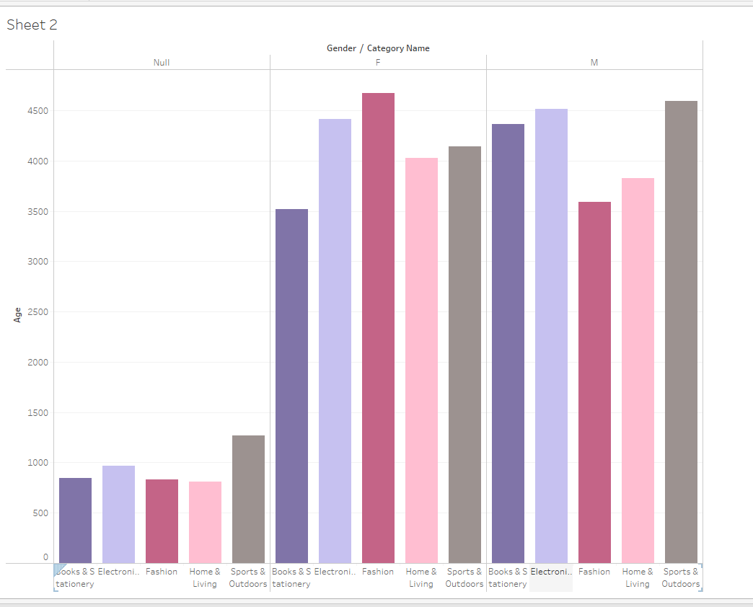
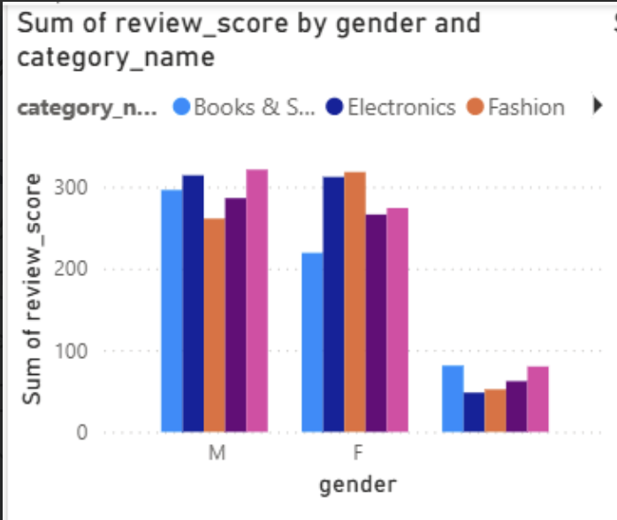
B. Quantity by Product Category
The donut chart demonstrates that Electronics (21.99%) and Sports & Outdoors (21.21%) are the leading categories, followed by Fashion, Books & Stationery, and Home & Living. This reflects a diverse product mix with consistent customer demand.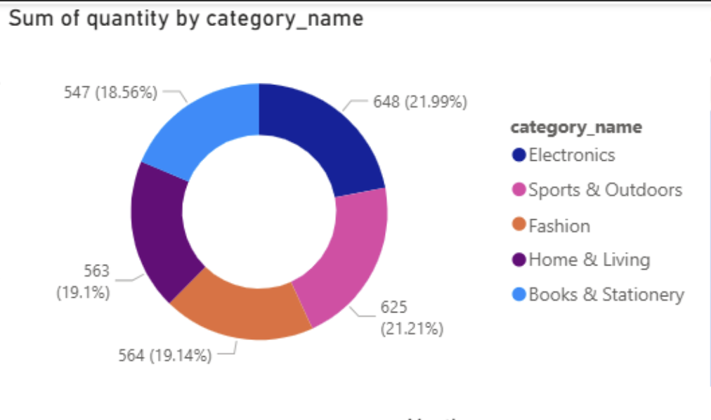
C. Geographic Distribution
The map visualization reveals a wide customer base across 962 cities globally, with clusters in North America, Europe, and Asia. Urban regions show higher female participation, suggesting broader digital adoption in metropolitan areas.
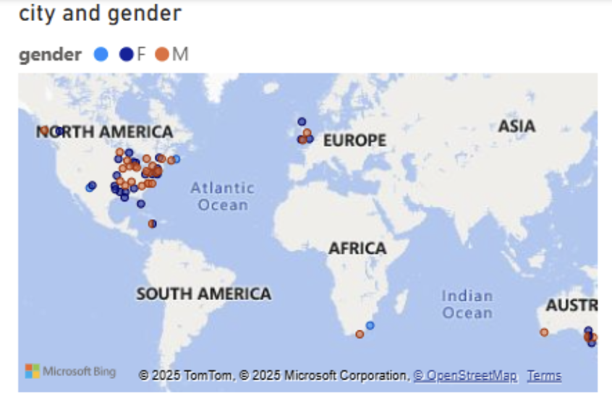
D. Key Influencers Analysis
The Key Influencers visual identifies quantity and price as the most influential factors driving sales.
- When quantity increases by 1.41, the average total sales rise by ₹347.4.
- When price increases by ₹139, total sales increase by approximately ₹406.
This correlation confirms that high-priced items and higher purchase volumes significantly impact total revenue.
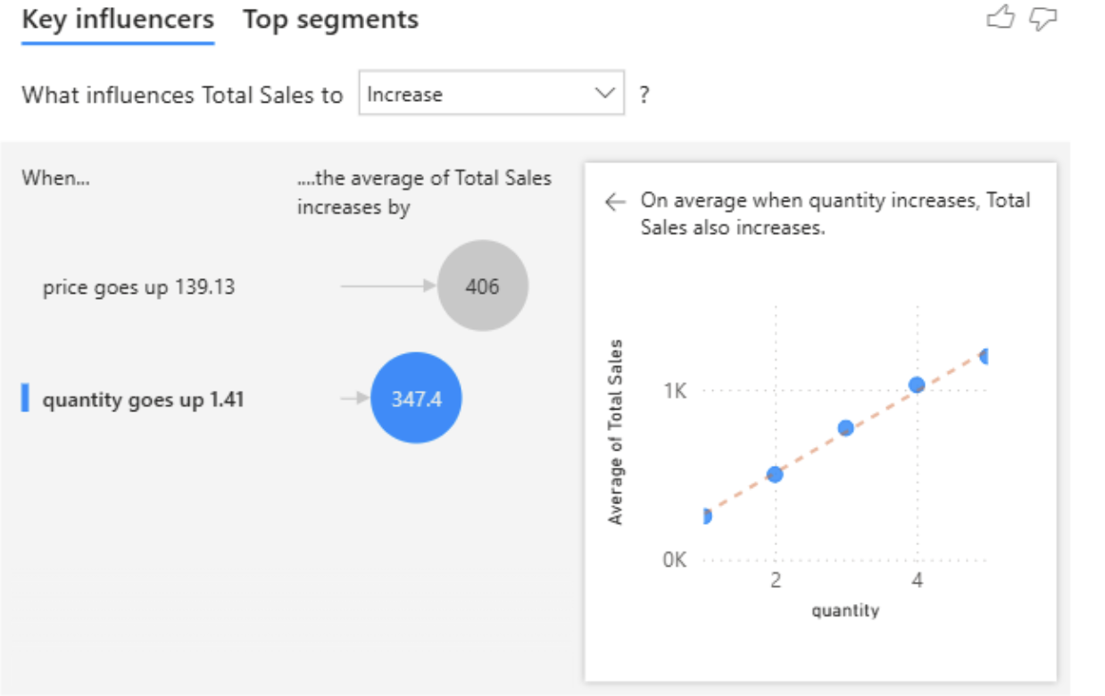
E. Decomposition Tree and KPI Summary
The KPI section displays:
- Total Revenue: ₹251.85K
- Cities Covered: 962
- Total Quantity Sold: 2,947 unit
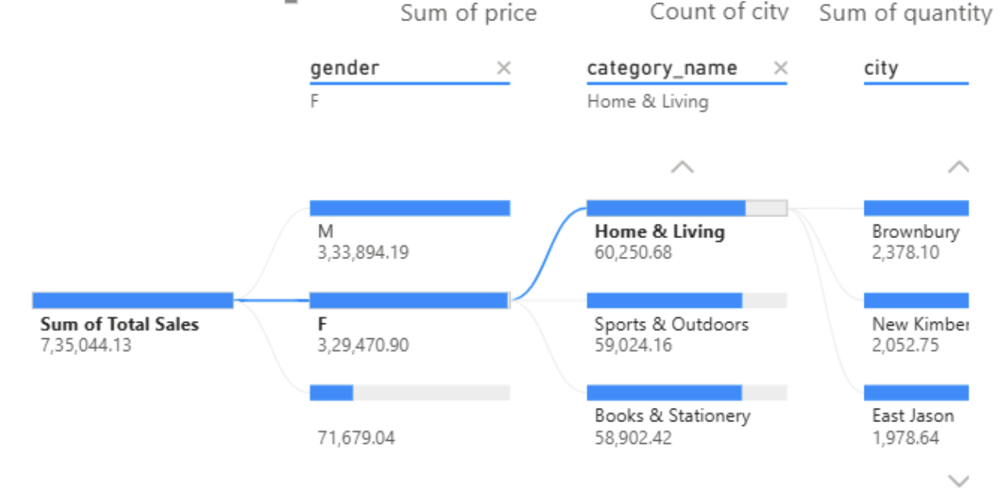
Decomposition Tree reveals that male customers contribute slightly higher total sales (₹333,894) compared to females (₹329,470). Home & Living, Sports & Outdoors, and Books & Stationery categories show nearly balanced performance across genders.

IV. RESULTS & DISCUSSION
From the dashboard analyses, several patterns emerge:
- Sales Distribution:
Electronics and Sports categories generate the highest revenue, highlighting the dominance of technology and lifestyle-based products.
- Customer Demographics:
Mature customers (ages 41–60) account for the largest share of spending, suggesting financial stability and stronger purchasing power within this age group.
- Payment Preferences:
Cash on Delivery remains the most popular method, indicating continued consumer reliance on traditional payment systems.
- Customer Satisfaction:
The overall average review score of 3.99/5 demonstrates high satisfaction levels, with Sports products achieving the highest ratings.
- Predictive Insights:
Price and quantity have a strong positive correlation with sales, providing actionable guidance for marketing and inventory strategies.
The analysis confirms that interactive visualization simplifies complex datasets into understandable business insights, revealing not just what sells, but why it sells.
COMPLETED DASHBOARD
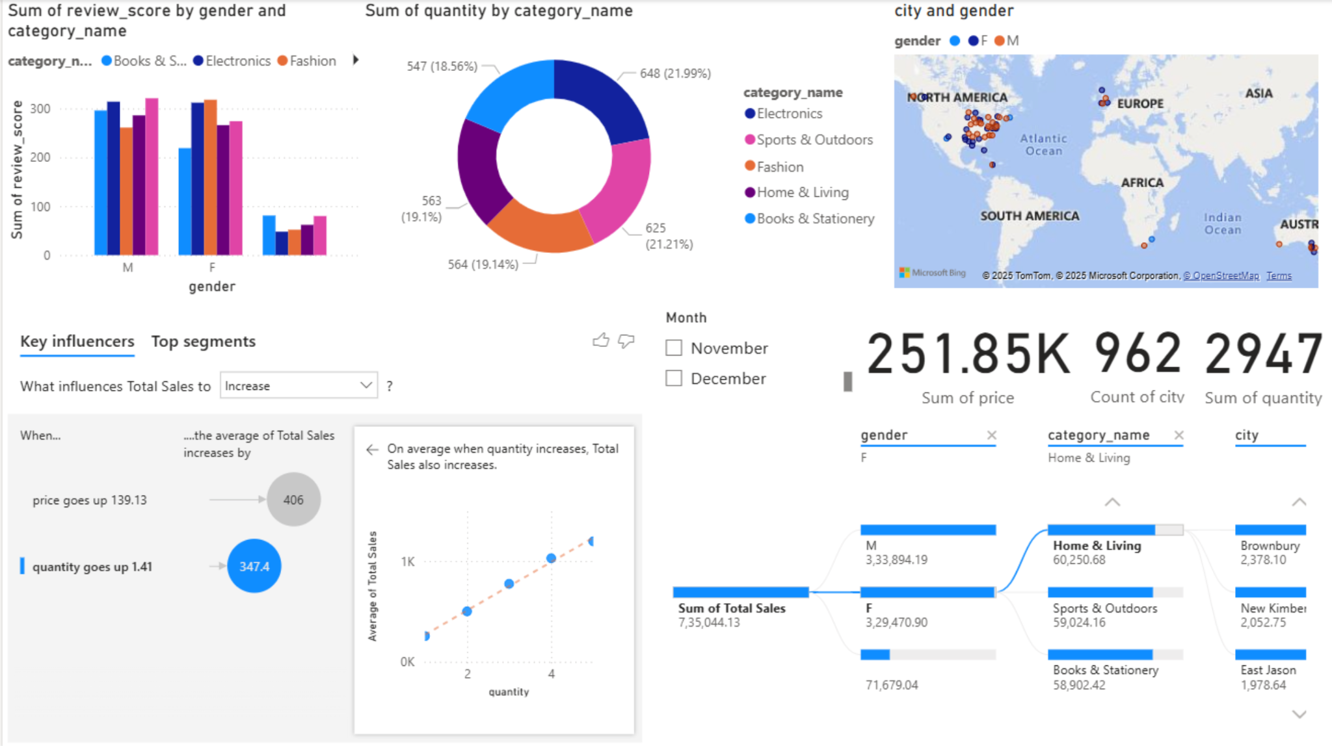

V. CONCLUSION
This study demonstrates how data analytics and visualization tools can effectively convert raw retail data into meaningful business insights. Using Python for preprocessing and Power BI and Tableau for visualization, the project identified patterns in sales, customer demographics, and satisfaction levels.
Results show that Electronics and Sports & Outdoors categories dominate performance, while mature customersrepresent the most profitable demographic. The findings highlight the importance of customer segmentation and pricing in driving sales. Overall, the dashboards illustrate how data visualization empowers decision-making, offering businesses a clear and interactive way to understand market dynamics.

ACKNOWLEDGMENT
The author expresses gratitude to Dr.Rupali Patil, Associate Professor, Department of EXTC, K. J. Somaiya College of Engineering, for valuable guidance, support, and constructive feedback throughout the project. Appreciation is also extended to the institution for providing resources and technical infrastructure essential for this study.

REFERENCES AND RESOURCES
[1] Kaggle, “Online Retail Dataset,” Available: https://www.kaggle.com/datasets/ertugrulesol/online-retail-data?resource=download
[2] Microsoft, “Power BI Documentation,” Available: https://powerbi.microsoft.com/
[3] Tableau Software, “Tableau Desktop: Technical Overview,” Available: https://www.tableau.com/

